Creating org Microsoft account
This guide walks through the steps required to create a Microsoft Entra ID tenant while signing up for an Azure free trial. The process consists of three main stages:

Start the Azure Free Trial
- Navigate to the Azure sign-up page.
https://azure.microsoft.com/en-gb/free/entra-id
- Select Try Azure for free.
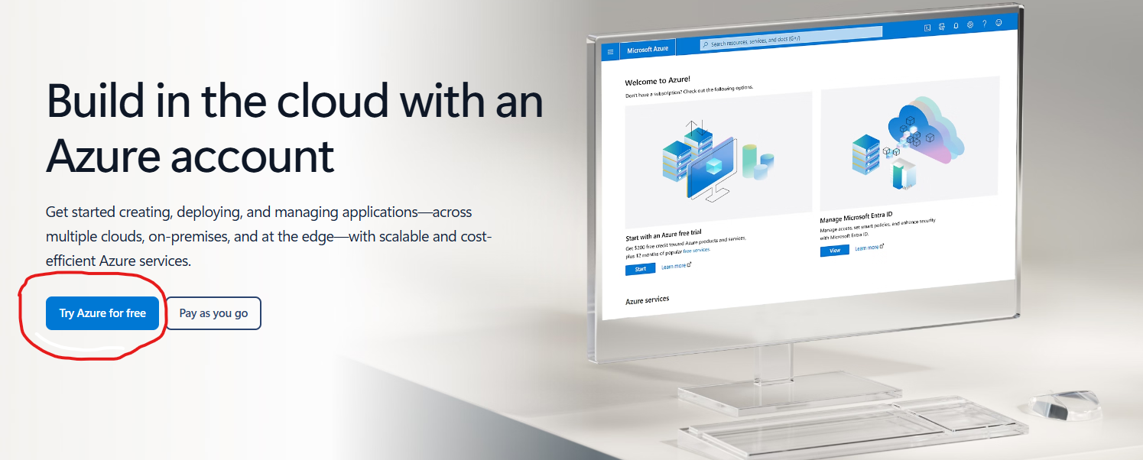
- You will be prompted to sign in with an existing Microsoft account or create a new one.
- After signing in, the system begins a three-step registration process.

Step 1 of 3 — Organization & Contact Information
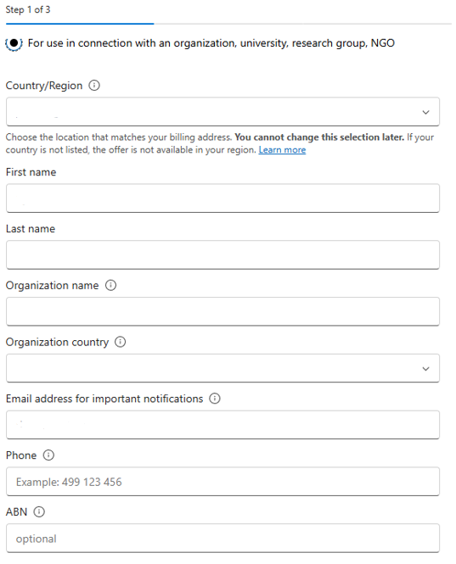
This step establishes who is creating the tenant and which organization it belongs to.
Fields to Complete
Field | What to Enter | Notes
Personal use or for organization | Choose “for use in connection with an organization…” | Cannot be changed later
Country/Region | Select the country that matches your billing address | Cannot be changed later
First name | Your legal first name | Used for identity verification
Last name | Your legal last name | Used for identity verification
Organization name | Name of your organization | This becomes part of your Azure billing profile
Organization country | Country where the organization is registered | Often auto-filled based on earlier selection
Email address for important notifications | Your work email | Azure sends billing, security, and service alerts here
Phone | A valid mobile or landline number | Used for identity verification
ABN (optional) | Leave this section empty | Optional but recommended for organizations in Australia

Step 2 of 3 — Address & Agreements
This step collects your physical address and requires you to accept Microsoft’s terms.
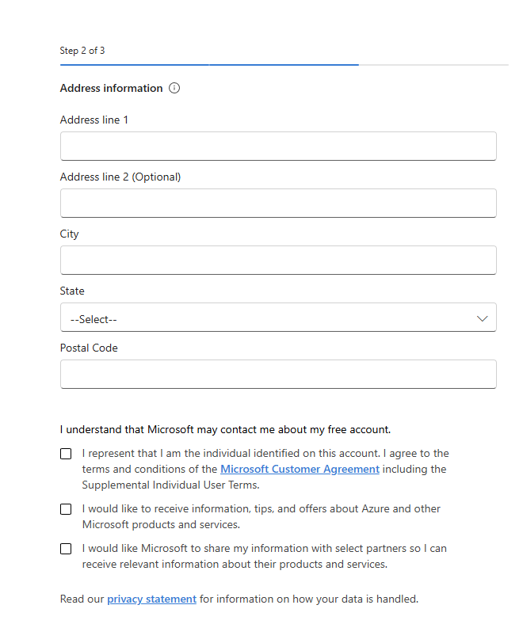
Fields to Complete
Field | What to Enter | Notes
Address line 1 | Primary business address | Required
Address line 2 | Suite, unit, or building info | Optional
City | City or suburb | Required
State | Select from the dropdown | Required
Postal Code | Valid postal code | Required; form will not continue without it
Required Agreements
You must check the box confirming:
- You are the individual identified on the account, and you agree to the Microsoft Customer Agreement and Supplemental Individual User Terms
Optional Communication Preferences
You may choose to opt in to:
- Product updates, tips, and offers from Microsoft
- Information from Microsoft partners
These do not affect your ability to proceed.

Step 3 of 3 — Payment Verification
Azure requires a valid payment method to prevent fraud and confirm identity. You will not be charged unless you later upgrade to Pay-As-You-Go.
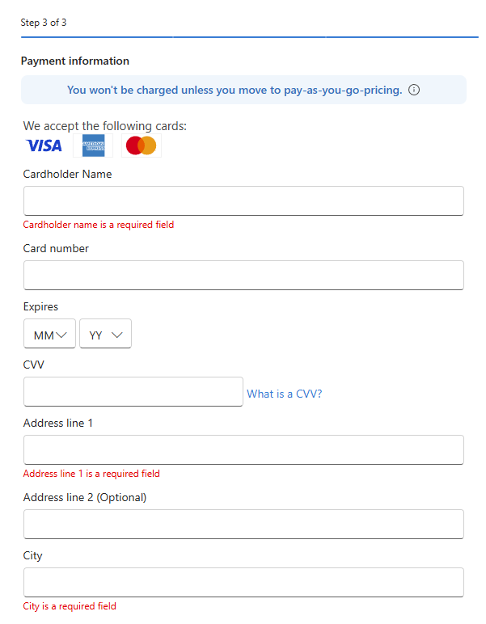
Fields to Complete
Field | What to Enter | Notes
Cardholder Name | Name exactly as it appears on the card | Required
Card Number | Valid Visa, Mastercard, or American Express | Required
Expiry (MM/YY) | Select month and year | Required
CVV | 3- or 4-digit security code | Required
Address line 1 | Billing address for the card | Required
Address line 2 | Optional
City | City or suburb | Required
State | Select from the dropdown | Required
Postal Code | Valid postal code | Required
Purpose of This Step
- Identity verification
- Fraud prevention
- Ensures eligibility for the free trial
Once submitted, Microsoft will validate your card and complete the tenant creation.
5. Completion
After all, three steps are successfully submitted:
- Your Azure subscription is created
- Your Microsoft Entra ID tenant is provisioned
- You can immediately begin configuring users, groups, applications, and security settings

